##### Academic Research Project- Not a Recommendation

**Prepared by – Aman Raj**

**Relative Stock Performance - 1Y**

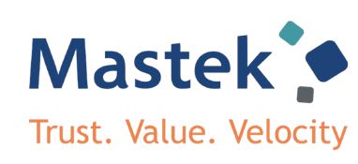

|  |  |
| --- | --- |
| **Recommendation** | **: XXX** |
| **CMP** | **: 2,431** |
| **Target Price** | **: XXX** |

|  |  |
| --- | --- |
| **Stock Data** | |
| Nifty | : 24,868.60 |
| 52 weeks H/L (INR) | : 3,375/1,887 |
| Market Cap (INR Cr.) | : 7,990 |
| O/S shares | : 3,09,39,894 |
| Dividend Yield % | : 0.91% |
| NSE Code | : MASTEK |

|  |  |
| --- | --- |
| **Shareholding pattern** | |
| **Promoters** | **: 35.96%** |
| **FIIs** | **: 11.05%** |
| **DIIs** | **: 10.52%** |
| **Government** | **: 0.00%** |
| **Public** | **: 42.47%** |

|  |  |  |  |
| --- | --- | --- | --- |
| **Financial Summary** | | | |
| **In INR Cr.** | **FY25** | **FY26E** | **FY27E** |
| **Net Revenue** | 3,455.23 | 4,099.79 | 4,877.98 |
| ***Growth YOY%*** | *13.11%* | *18.66%* | *18.98%* |
| **EBITDA** | 546.45 | 759.27 | 903.36 |
| ***EBITDA %*** | *15.8%* | *18.5%* | *18.5%* |
| **Adj PAT** | 3,75.93 | 588.24 | 709.10 |
| **ROE %** | 16.53% | 21.68% | 21.70% |
| **Adj EPS (INR)** | 121.78 | 190.56 | 229.72 |
| **EV/EBITDA(x)** | 12.8x | 11.1x | 8.5x |

|  |  |
| --- | --- |
| **Absolute Return** | |
| **1 Year** | **: -11.25%** |
| **3 Years** | **: 36.63%** |
| **5 Years** | **: 260.84%** |

Nifty

Mastek

***September 25***

***December 24***

***March 25***

***June 25***

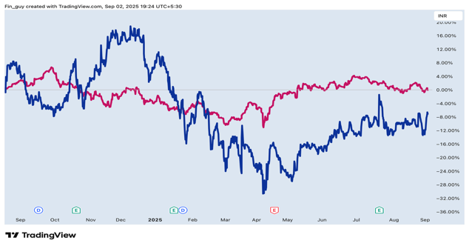

**Equity Research Report**

# Mastek Ltd.

# (Driving Digital Transformation)

# About the Company

**Mastek Limited**(hereinafter referred to as “**Mastek**” or “thecompany”) was incorporated in **1982**as**Management and Software Technology Pvt Ltd** by**Ashank Desai, Ketan Mehta, and R. Sundar,** laterjoinedby**Sudhakar Ram.** Headquarteredin**Mumbai,** Mastekhasgrownintoa**leading digital engineering and cloud transformation partner** withastrong**global footprint.** The company operatesacross**digital and application engineering, Oracle cloud and enterprise solutions, data, automation and AI,** as well as **digital commerce and experience**.

Mastek is recognized among the **top IT services providers** with expertise spanning **public sector, healthcare, retail, financial services, and insurance**. It has delivered **large-scale mission critical projects**including **government programs in the UK**, and **enterprise-wide digital transformation solutions** across **North America, Europe, and Asia-Pacific**.

Currently, the company serves clients in **40+ countries** through its **global delivery centers**, with a primary **revenue base from the UK, North America, and AMEA markets**. Mastek has consistently invested in **capability building, innovation, and acquisitions** to enhance its **service offerings.** Recent acquisitions such as **Evosys** and **BizAnalytica** have further strengthened its position in **Oracle Cloud services** and **data-driven transformation**.

**Overall View**

* **Healthy revenue growth** of 13.1% YoY (₹3,455.2 cr), though operating EBITDA margin moderated to **15.8% in FY25 vs. 16.7% in FY24**. Growth momentum is expected to continue, driven by (1) strong deal wins with **48 new logos**, (2) robust traction in the **US geography** (27% of revenue), (3) sustained strength in **UK public sector engagements** (57.3% of revenue), and (4) the scaling of **AI/ML-led solutions** across verticals.
* **Revenue growth was volume-led**, supported by **96.4% repeat business ratio** and client additions, in contrast to the broader IT industry where growth was relatively subdued and pricing-driven.
* **Margins reflected service mix improvements**, with an increasing share of digital and AI/ML engagements, though employee cost pressures and offshore mix shifts led to a marginal decline in EBITDA margin to 15.8%

# 

# Key Highlights

# **Mastek reported Q1FY26 revenue of ₹914.7 crore**, up **12.5% YoY** (6.8% in constant currency) and **1.0% QoQ**.

# **Operating EBITDA stood at ₹137.3 crore**, with margins at **15.0%**, reflecting a slight sequential moderation from 15.3% in Q4FY25.

# **PAT came in at ₹92.1 crore**, a **28.7% YoY** increase and **13.5% QoQ** growth, supported by profitability improvements.

# **12-month order backlog stood at ₹2,147.9 crore**, up **8.3% YoY**, though down marginally **2.5% QoQ**, indicating continued healthy deal momentum.

**Academic Research Project- Not a Recommendation**

**Academic Research Project- Not a Recommendation**

**Economic analysis**



# Global Economy

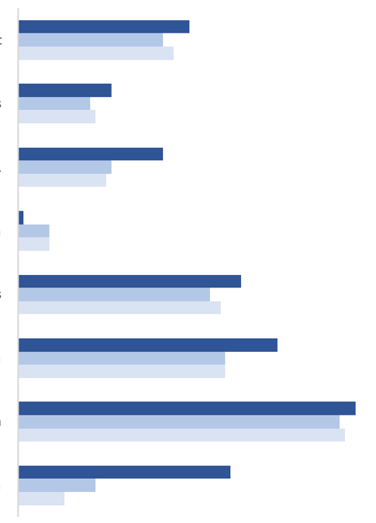

**0.6% 1.6% 2.6% 3.6% 4.6% 5.6% 6.6%**

**Global GDP Growth(%)**

**2024 2025 2026**

**India**

**Russia**

**Emerging Markets**

**China**

**USA**

**Adv. Economies**

**Japan**

**World Output**

*Source: IMF*

The global economy in CY25 is navigating a period of transition, balancing moderate growth with persistent headwinds from geopolitical tensions, trade frictions, and demographic shifts. After expanding by 3.5% in CY23 and easing to 2.8% in CY24, global GDP growth is projected at **2.8% in CY25** and **3.0% in CY26**.

Advanced economies are expected to remain modest, growing by **1.4% in CY25** and **1.5% in CY26**, supported by monetary policy easing and stabilization in real incomes. The United States continues to show resilience through strong labour markets and consumer spending, while the Eurozone faces structural inefficiencies and Japan contends with demographic pressures.

In contrast, **emerging markets** are anticipated to grow faster at **3.7% in CY25** and **3.9% in CY26**, led by India and Southeast Asia on the back of robust domestic demand, rapid digital adoption, and infrastructure investment. However, escalating trade tensions, including new U.S. tariffs on over 90 countries, pose risks of higher costs and inflation. Despite this, resilience will be supported by technology-led productivity gains and strategic policy responses.

### Real GDP Growth Rate (%)

**-5.8%**

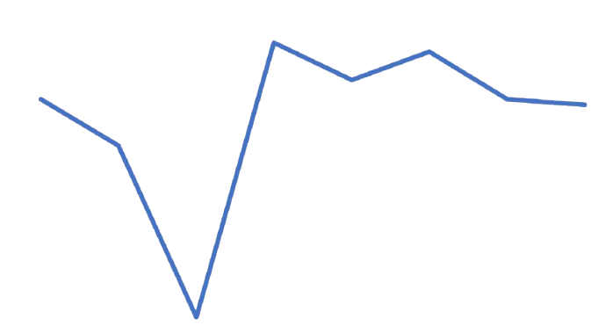

**3.9%**

**7.6%**

**9.7%**

**9.2%**

**6.5%**

**6.2%**

**6.5%**

**FY18 FY19 FY20 FY21 FY22 FY23 FY24 FY25**

*Source: IMF*

## Indian Economy

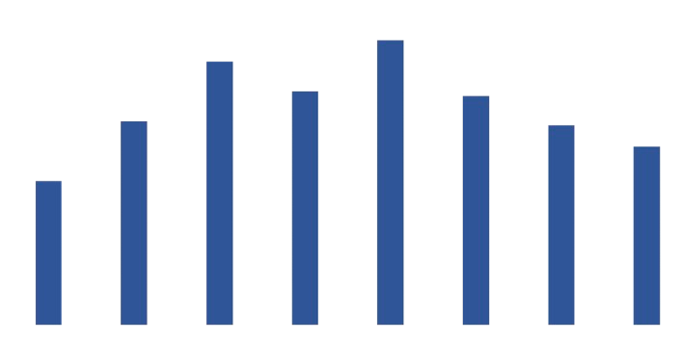

**3.4%**

**4.8%**

**6.2%**

**5.5%**

**6.7%**

**5.4%**

**4.7%**

**4.2%**

**FY18 FY19 FY20 FY21 FY22 FY23 FY24 FY25**

*Source: IMF*

**Inflation Trend over the Years**

India continues to be one of the fastest-growing major economies, supported by demographic advantages, strong domestic demand, and structural reforms. In FY25, GDP growth moderated to **6.5%**, down from **9.2% in FY24**, according to MOSPI. The slowdown reflects weaker manufacturing activity, persistent food inflation, limited job creation, and subdued private investment. Urban consumption also softened, while a widening trade deficit added to macroeconomic pressures. Despite these challenges, India’s services sector, robust infrastructure push, and policy-led initiatives such as digital transformation and financial inclusion have supported resilience in the overall growth trajectory.

Inflation remained a key concern during FY25, averaging **4.6%** compared to **5.4% in FY24**, influenced by global supply chain disruptions and volatile commodity prices. In response, the **RBI Monetary Policy Committee** reduced policy rates by **100 basis points** over three reviews starting February 2025, bringing the repo rate to **5.5% by June 2025**. This easing is aimed at stimulating investment and consumption without compromising price stability.

Looking ahead, India’s growth outlook remains optimistic. GDP is projected to expand by **6.5% in FY26**, driven by government programs such as the **PLI scheme**, investment in infrastructure, renewable energy, and accelerated digitalisation. With sustained reforms, India is expected to become the **world’s third-largest economy by FY28**, with GDP projected at **USD 5.7 trillion**.

 **Academic Research Project- Not a Recommendation**

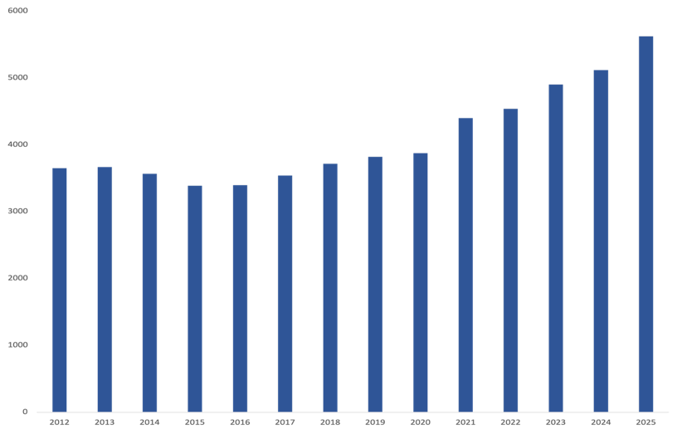

**Global IT Market Spending by Value (US $ Billion)**

*Source: Gartner Report on World IT Spending*

**FY12 FY13 FY14 FY15 FY16 FY17 FY18 FY19 FY20 FY21 FY22 F Y23 FY24 FY25**

**3,648**

**3,663**

**3,563**

**3,385**

**3,394**

**3,538**

**3,714**

**3,817**

**3,872**

**4,397**

**4,533**

**4,898**

**5,115**

**5,618**

**CAGR 3.0 - 3.5 %**

**IT Industry**

## Global IT Industry

The Global Information Technology (IT) industry has grown rapidly over the past few years, supported by accelerating digital transformation, cloud adoption, and increasing demand for automation and cybersecurity. The global IT services market, valued at **USD 1.50 trillion in CY24**, is projected to grow at a **CAGR of 9.4% from CY25–CY30**, reflecting the industry’s central role in enabling business agility and resilience. This outlook is further reinforced by robust global IT spending, which is expected to reach **USD 5.62 trillion in CY25**, marking a **9.8% increase over CY24**. Software is projected to drive the highest growth at **23.2%**, followed by data centre systems (**14.2%**) and devices (**10.4%**), while IT services are expected to grow by **9%**.

Traditionally, IT innovation and spending have been concentrated in developed markets such as **North America and Europe**, which continue to account for a large share of value owing to advanced technology adoption and higher enterprise budgets. However, in recent years, middle-income countries like **India, China, and Brazil** have emerged as significant growth drivers, supported by rising IT exports, cloud investments, and infrastructure expansion. Emerging technologies, particularly **Generative AI**, are reshaping the industry, with spending on AI-optimized servers forecasted to reach **USD 202 billion in CY25**, led by hyperscalers.

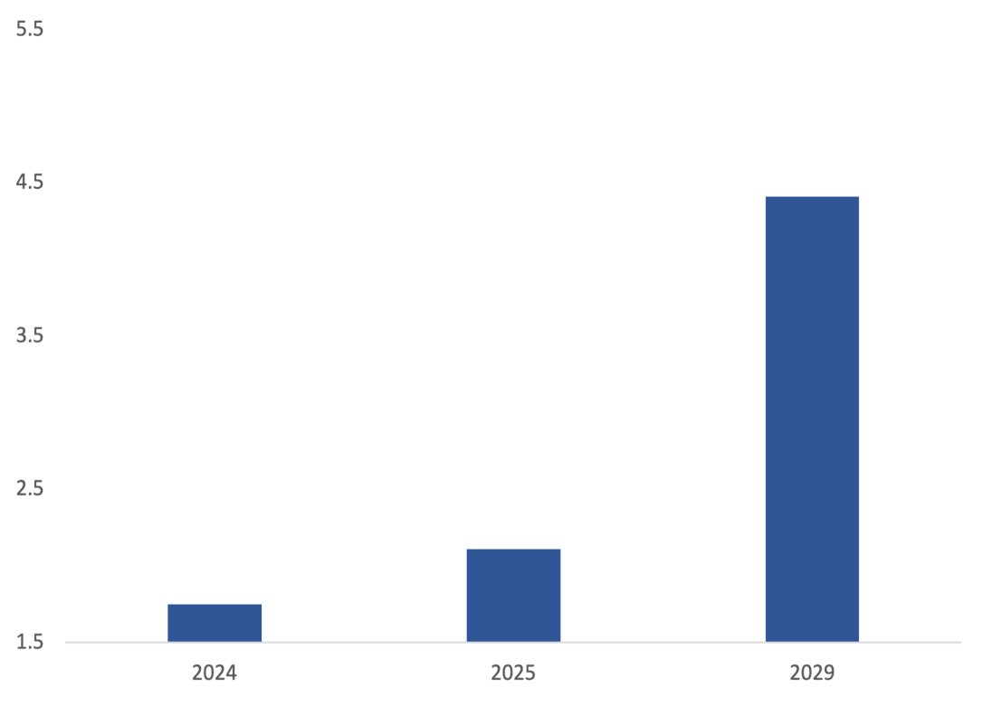

##### Global Digital Transformation Market (AI) in USD Trillion

**FY24**

**FY25**

**FY29**

**USD 1.75**

**USD 4.41**

**USD 2.11**

**CAGR 20 - 21 %**

*Source: Company Annual Report*

##### 

The digital transformation sector is experiencing rapid growth driven by emerging market expansion, widespread 5G rollout, and increased enterprise investment in digital technologies.

Key enablers include rising mobile usage, broader internet access, and growing demand for automation across industries. Continued momentum is expected as businesses prioritise innovation, efficiency, and connectivity.

##### Segmentation of global IT market

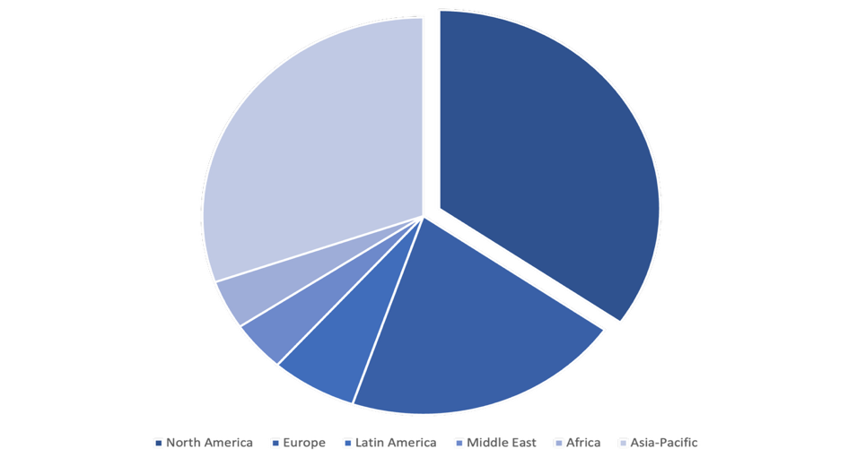

**Africa 4.0%**

**Europe**

**20.50%**

**North America 34.70%**

**Asia**

**30.40%**

**South America 6.30%**

**Middle East. 4.10%**

*Source: Company Annual Report*

Key Trends in Global IT Market

The global IT industry is set for steady growth in CY25, driven by increasing investments in **digital transformation**, **AI**, **cloud infrastructure**, and **software.** Businesses are prioritising operational efficiency, agility, and innovation, with **AI** emerging as a key enabler of automation, personalisation, and smarter decision-making.

Evolving **regulatory and tax requirements** are pushing companies to modernise internal systems, particularly in **ERP** and **data governance**, enhancing transparency and compliance. Demand for **cybersecurity**, **intelligent infrastructure**, and **cloud-native solutions** is reshaping IT spending patterns, while emerging markets are gaining momentum as delivery hubs due to **skilled talent** and **cost advantages**. These regions play a growing role in providing **complex IT services** and **outsourced digital capabilities**.

Demographic shifts, such as a growing **digitally native population** and **rising internet penetration,** are expanding the digital economy. As businesses scale their digital capabilities, the IT sector is well-positioned to deliver **resilient, secure, and future-ready-Solutions**

**Academic Research Project- Not a Recommendation**

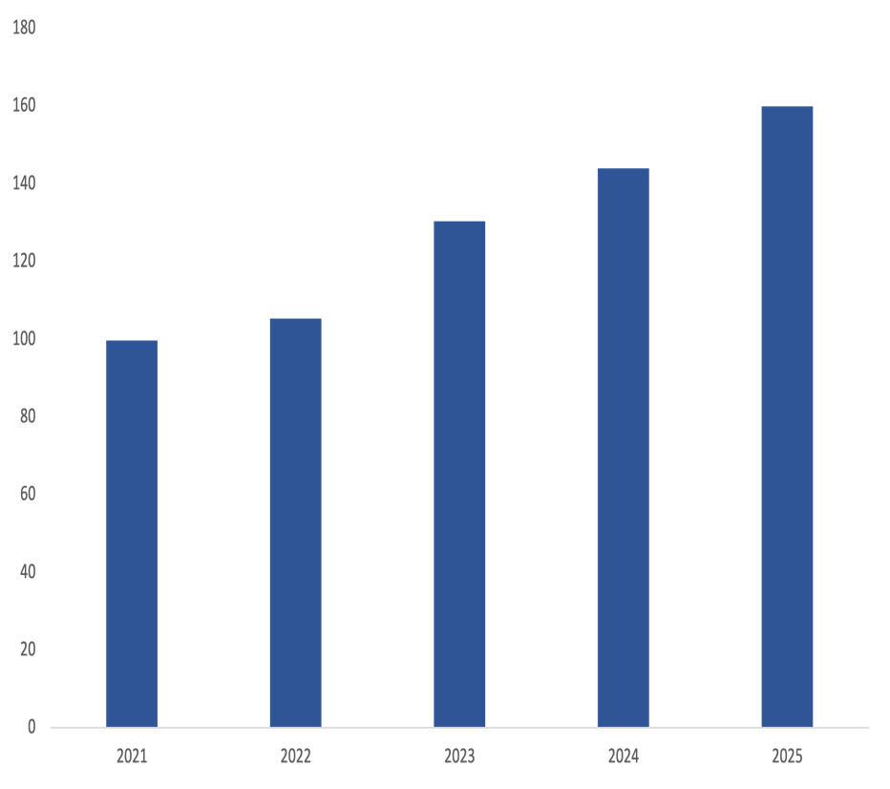

#### Indian IT Spending Growth (US $ Billion)

**100**

**160**

**CAGR 9 – 10 %**

*Source: Mastek Annual Report*

**FY25**

**FY24**

**FY23**

**FY22**

**FY21**

**IT Industry**

# Indian IT Industry

The **Indian Information Technology (IT) industry** has emerged as a cornerstone of both the **domestic economy** and the **global digital ecosystem**. With a strong focus on **technology-led services**, **product engineering**, and **digital transformation**, India has positioned itself as a preferred destination for global enterprises. As of **FY24**, the country is home to more than **1,750 Global Capability Centers (GCCs)**, highlighting a shift towards **high-value and innovation-driven work**. According to **Gartner**, **India’s overall IT spending** is expected to grow from **USD 143.9 billion in 2024**to **USD 159.96 billion in 2025**, recording a **growth rate of 11.2%**. Leading this growth are the **software** and **IT services** segments, with projected growth rates of **17.0%** and **11.4%**, respectively.

India's **data centre** and **cloud ecosystem** is expanding rapidly, driven by **digital transformation** and post-COVID demand for **cloud services. Google** recently opened its largest Indian campus—**Ananta**—in **Bengaluru**, spanning **1.6 million sq. ft** and accommodating **5,000+ employees.** India is now the **second-fastest growing data centre market** in **Asia-Pacific,** with capacity up **28%** and projected to grow from **$5.42 billion in 2022** to **$9.96 billion** by **2028.** Data centre capacity is expected to **double** from **0.9 GW** **2023** to **2 GW by 2026.** **Reliance** plans to build the **world’s largest data centre** in **Jamnagar** as it enters the **AI space.** Total investments in Indian data centres are set to reach **$28 billion 2019–2025,** growing **5.2x faster** than the **global average.**

The industry is undergoing rapid evolution through the adoption of **Artificial Intelligence (AI)**, **cloud computing**, **Robotic Process Automation (RPA)**, and **Natural Language Processing (NLP)**. These technologies are enabling **cost reduction**, **scalable operations**, and **enhanced decision-making**. The **Digital India programme**, along with the country’s over **760 million internet users**, continues to improve **access to digital infrastructure** and promote **citizen-centric services**.

India’s **software product industry** is projected to reach **USD 100 billion by 2025**, driven by international expansion and the development of **global delivery capabilities**. The industry is expected to contribute **10% to India’s GDP by 2026**. Additionally, the **India AI Mission** aims to establish India’s first **homegrown GPU** by 2025, further boosting the country’s innovation ecosystem.

With a **deep talent pool**, **cost-efficient delivery models**, and rising interest in the **China+1 supply chain strategy**, the Indian IT sector is strategically placed for sustained long-term growth, making it a **compelling area of focus for equity investors**.

*Source: IBEF, Company Annual Reports & Gartner Report*

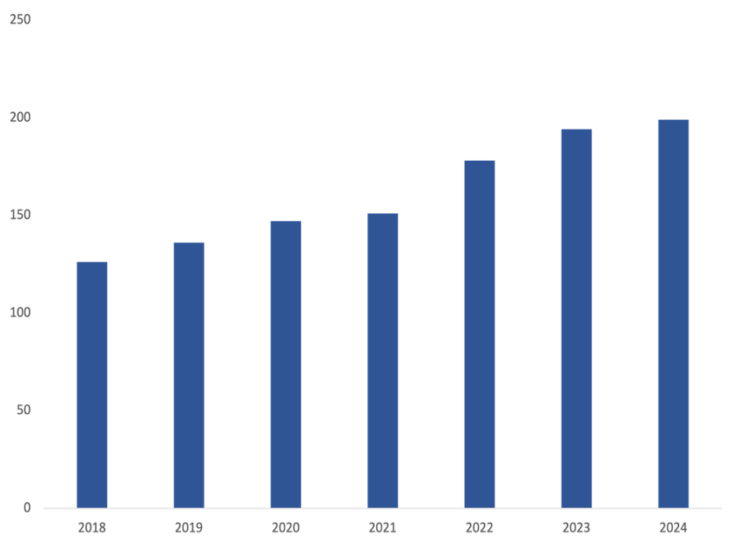

#### Export Revenue from Indian IT Industry (US$ billion)

**FY18**

**FY19**

**FY20**

**FY21**

**FY22**

**FY23**

**FY24**

**126**

**136**

**147**

**151**

**178**

**194**

**199**

**CAGR – 6 – 7%**

*Source: IBEF*

India continues to demonstrate strength in **IT exports**, which stood at **USD 199 billion in FY24**, and are expected to reach **USD 210 billion in FY25**. Exports are primarily driven by **IT services**, **Business Process Management (BPM)**, **software products**, and **engineering and R&D services**. Mid-tier IT firms have outperformed larger peers in **FY25**, showcasing adaptability and sector-specific expertise. However, sustainability of this momentum will depend on **macroeconomic stability** and **technological investments**.

**Academic Research Project- Not a Recommendation**

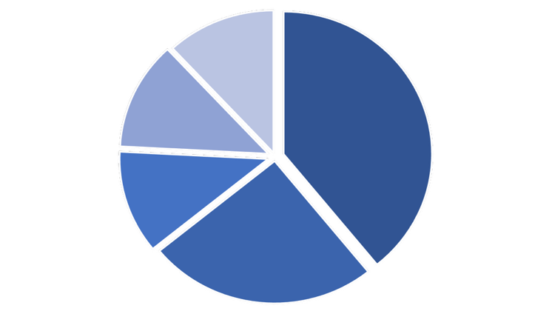

**Revenue breakup by Industry Segments**

**39.2%**

**25.0%**

**11.7%**

**12.3%**

**11.9%**

**Retail & Consumer**

**Financial Services**

**Government & Education**

**Health & Life Sciences**

**Manufacturing & technology**

**Earnings Call Analysis**

**Q1 FY26**

**Mastek reported a resilient performance in Q1FY26**, delivering strong growth across key financial metrics and maintaining healthy return ratios. **Consolidated revenue** for the quarter stood at **₹914.7 crore**, marking a **12.5% year-on-year (YoY) increase**. In USD terms, revenue reached **$107.4 million**, reflecting a **10.4% YoY growth**. This growth was driven by sustained demand for digital transformation services, particularly in the **UK and US markets**.

Operationally, **EBITDA for the quarter stood at ₹137.3 crore**, up **10.8% YoY**, despite a slight contraction in margins. **EBITDA margin came in at 15.0%**, compared to **15.2% in Q1FY25**, impacted by ongoing investments in capability expansion and talent acquisition. **Profit Before Tax (PBT)** rose **22.4% YoY** to **₹120.7 crore**, while **Net Profit (PAT)**surged **28.7% YoY** to **₹92.1 crore**. A sharp rise in **other income (₹10.6 crore, up 152% YoY)** also contributed to the bottom-line growth, suggesting effective treasury management or non-recurring gains.

**Earnings per Share (EPS)** showed significant improvement, with **basic EPS at ₹29.7**, compared to **₹23.2 in Q1FY25**. The company’s **12-month order backlog** grew to **₹2,347.9 crore (~$274 million)**, indicating robust demand visibility and a strong deal pipeline across digital engineering, cloud, and data-driven offerings.

On the balance sheet front, **cash and cash equivalents stood at ₹549.0 crore**, lower than **₹622.2 crore in FY25**, largely due to reinvestment in operations and working capital requirements. Nevertheless, the company retains a healthy liquidity position with a debt-light structure. Return metrics continued their upward trajectory — **Return on Equity (ROE)**improved to **16.7%**, up from **16.5% in FY25**, while **Return on Capital Employed (ROCE)** increased to **17.0%**, compared to **16.9%** in the previous fiscal year.

Looking forward, **Mastek remains optimistic** about the business outlook for the remainder of FY26. With a strong focus on next-gen technologies such as **GenAI, automation, and cloud modernization**, the company is well-positioned to capture emerging opportunities. Management reiterated its commitment to **profitable growth**, margin expansion, and continued investments in innovation, delivery excellence, and customer success.

*Source: Mastek Q1FY26 Report*

*Source: Mastek Q1FY26 Report*

**Management Outlook**

Mastek continues to demonstrate resilience and strategic focus, delivering a steady performance in Q1FY26. The management remains confident in sustaining growth, backed by strong execution in the UK and Europe, particularly within healthcare and secured government services. While the US business witnessed headwinds in a few client accounts, the overall pipeline and 12-month order backlog, which grew **8.3% YoY**, provide strong visibility for future growth.

During the quarter, **revenue grew 12.5% YoY**, and **PAT increased 28.7% YoY**, reflecting continued demand across core verticals and a sharp improvement in profitability. Although **EBITDA margin declined marginally by 31 bps** to **15.0%**, the dip was a result of ongoing investments in talent, delivery capabilities, and innovation – initiatives the management sees as essential for long-term competitiveness.

The company is gaining strong traction in **AI-led transformation**, having closed **over 10 deals** in the quarter across generative and agentic AI, helping clients realize significant productivity gains. A new **strategic partnership with Open Ana** further strengthens Mastek’s AI proposition and reinforces its commitment to becoming a key player in enterprise AI adoption.

Despite an uncertain global environment, Mastek remains focused on **sustainable and profitable growth**. Management will continue to invest in expanding digital offerings, deepening strategic client relationships, and scaling high-margin services across data, automation, and cloud. With a healthy balance sheet, strong order book, and strategic clarity, Mastek is well-positioned to capitalize on market opportunities and deliver consistent value to stakeholders in the quarters ahead.

**Academic Research Project- Not a Recommendation**

**Revenue Contribution by Clients**

*Source: Mastek Annual Report*

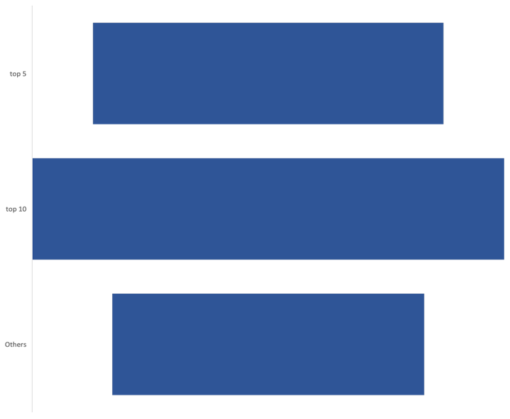

**30.9%**

**41.6%**

**27.5%**

**Top 5 Clients**

**Top 10 Clients**

**Other Clients**

**Business Outlook**

**3,600**

**3,000**

**2,400**

**1,800**

**1,200**

**600**

**6,000**

**5,000**

**4,000**

**3,000**

**2,000**

**1,000**

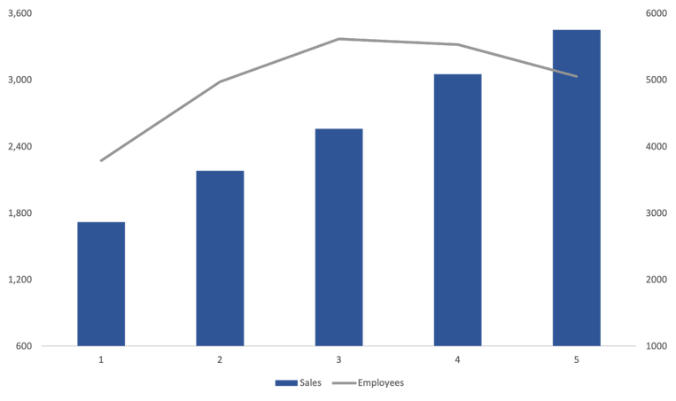

**Revenue (₹ Cr.) vs No. of Employees**

**FY21**

**FY22**

**FY23**

**FY24**

**FY25**

**Revenue No. of Employees**

*Source: Mastek Annual Report*

*Source: Mastek Annual Report*

**1,722**

**2,184**

**2,563**

**3,055**

**3,455**

**3,792**

**4,977**

**5,539**

**5,058**

**5,622**

**Top 5 Clients**

**Top 10 Clients**

**Other Clients**

*Source: Mastek Annual Report*

**Revenue by Geography**

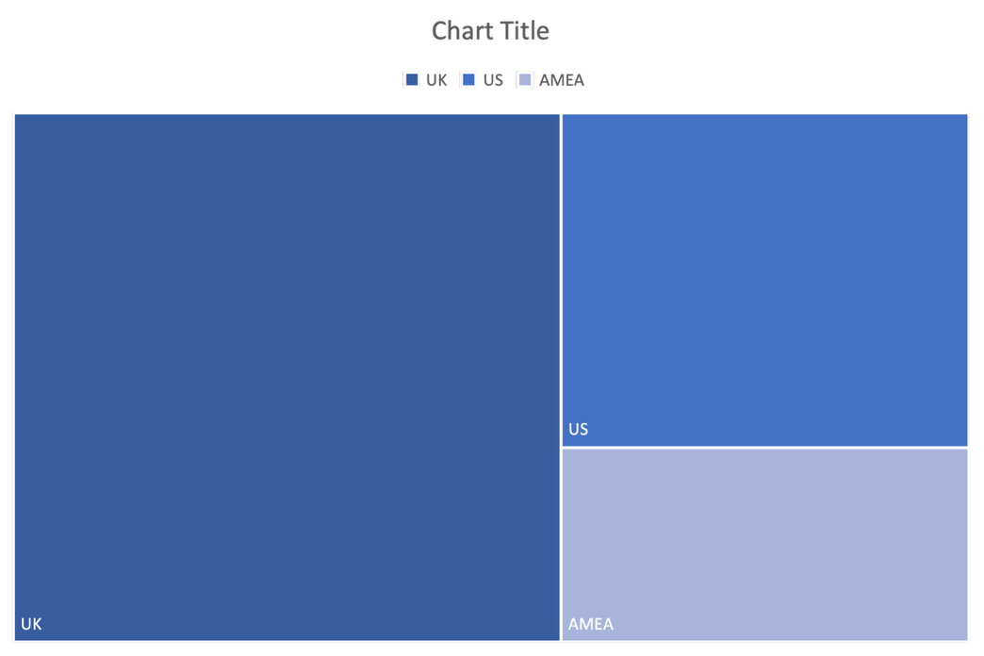

**UK**

**27.0%**

**US**

**15.7%**

**AMEA**

**57.3%**

**UK**

*Source: Mastek Annual Report*

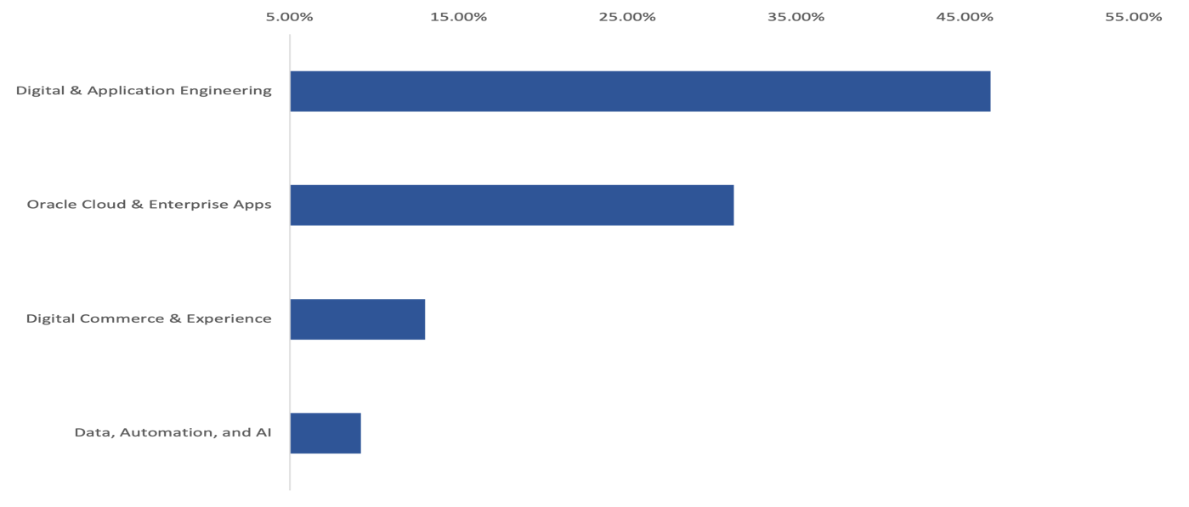

**5% 15% 25% 35% 45% 55%**

**Revenue by Service line**

**Digital & Application Engineering**

**Oracle Cloud & Enterprise Apps**

**Digital Commerce & Experience**

**Data, Automation, and AI**

**46.5%**

**13.0%**

**9.2%**

**31.3%**

**Academic Research Project- Not a Recommendation**

**Leadership Analysis**

**Board Of Directors**

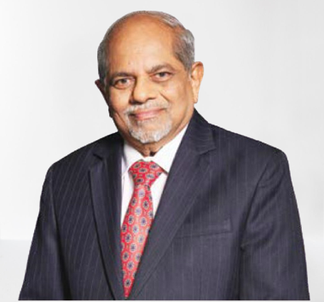

* **Mr. Ashank Desai****Co-founder & Chairman** of Mastek; co-founder & Past Chairman of NASSCOM.
* Over 40 years’ experience in IT, leading complex organizations.
* Felicitated by PM Modi for contributions to IT industry.
* Guides Mastek Foundation promoting responsible philanthropy.
* Recipient of IIT Mumbai Distinguished Alumnus, CSI Fellow, ASOCIO Award (twice), and APEA Outstanding Entrepreneur Award.

* **Mr. Umang Nahata, CEO** – Mastek Group; former Founder & CEO of Evosys, acquired by Mastek in 2020.
* Over 20 years of IT services experience, driving growth and global expansion.
* Former President of Mastek North America, APAC & ME; built international customer base.
* Chartered Accountant and Non-Executive, Non-Independent Board Member at Mastek.
* **Ms. Marilyn Jones, Independent Director**; MS in Education, Portland State University.
* 20+ years leading technology transformations at Intuit, Dell, Dun & Bradstreet, and Travelocity.
* Former Senior VP of Technology, managing 400+ professionals.
* Advisory Board Member at UT Dallas, Teradata, and Alliance of Women in Technology; recipient of Intuit CEO Leadership Award (2016) and Dallas Tech Titan CTO Award (2015).
* **Mr. Ketan Mehta** **Co-founder** of Mastek (1982) and Board Member; IIM Ahmedabad graduate.
* Over 40 years of IT experience, leading sales, delivery, and general management.
* Led Majesco’s insurance strategy, including acquisition of seven insurance tech companies.
* Former CEO & President of Majesco (USA) and Chairman during its sale to Thoma Bravo.

**Academic Research Project- Not a Recommendation**

**Leadership Analysis**

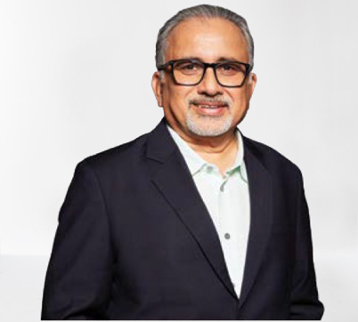

* **Mr. Suresh Vaswani, Independent Director** at Mastek; alumnus of IIT Kharagpur and IIM Ahmedabad.
* Seasoned global technology and IT services leader with expertise in building, scaling, and transforming businesses.
* Former President of Dell Services, Co-CEO & Board Member at Wipro, and General Manager at IBM Global Technology Services.
* Serves on boards of public, private equity, and early-stage companies.

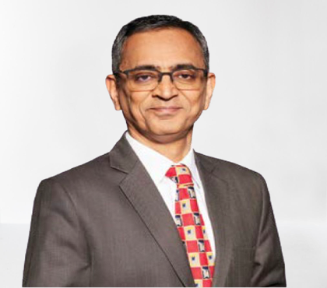

* **Mr. Rajeev Grover, Independent Director**; B.Com (Hons.) from Shri Ram College of Commerce; member of ICAI & ICSI.
* Over 30 years of experience across Finance, Operations, General Management & Business Transformation.
* Former Global Head of Operations at Mercer Consulting; pioneer in India’s Business Process Outsourcing industry.
* Founder Director of ExempServ Professional Services; Non-Executive Treasurer at SOS Children’s Villages of India.
* **Mr. Abhishek, President – UK Business**; MBA in Finance from IMDR, B.Com from Patna University.
* Over 20 years of experience across IT, Healthcare, Financial Services, and BPM industries in India and the US.
* Former Senior VP & Group Finance Controller at Firstsource Solutions; leadership roles at Tech Mahindra and Firstsource.
* Expertise in corporate performance management, financial planning, business efficiency, M&A, automation, and process optimisation.
* **Mr. Vimal Dangri, General Counsel & Chief Risk Officer** at Mastek; Law graduate from Karnataka State Law University and Masters in Business Laws from NLSIU, Bangalore.
* Over 24 years of experience in legal, risk, compliance, ethics, corporate governance, and quality management.
* Leads Mastek’s sustainability initiatives, cost efficiencies, and structural simplification strategies.
* Formerly headed legal, compliance, risk, and secretarial functions at Firstsource Solutions Limited.

**Key Managerial Personnel**



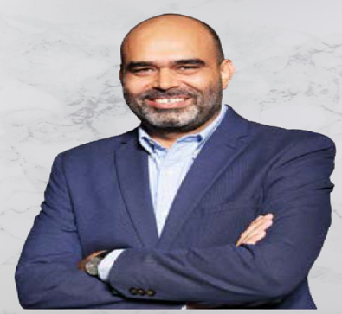

##### Academic Research Project- Not a Recommendation

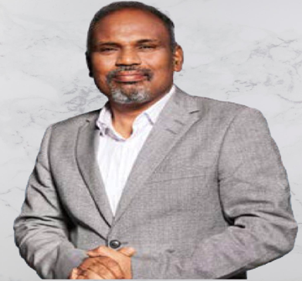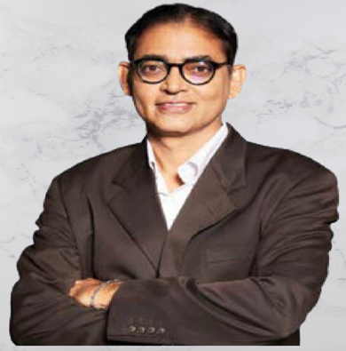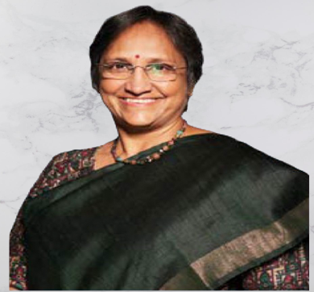

* **Ms. Prameela Kalive, Chief Operating Officer** at Mastek; over three decades of experience in the IT industry.
* First woman COO of the Indian IT industry; previously served 22 years as COO at Zensar Technologies.
* Former DRDO missile scientist, contributing to AGNI and AKAASH projects under Dr. A.P.J. Abdul Kalam.
* Holds master’s degrees in digital engineering and business administration; alumna of Osmania University, LSE, and ISB.
* Actively engaged in ESG forums; recipient of Chevening Scholarship (LSE), ‘Rising Star’ CEO Award (2015), and ‘Woman in Technology’ Award (2019).
* **Mr. Ritwik Batabyal, Chief Technology & Innovation Officer** at Mastek; B.Tech in Mechanical Engineering from NIT Kurukshetra.
* 26 years of IT and engineering experience, driving digital transformation, Data & AI monetisation, and technology integration.
* Former GDH – Platform & Solutions at L&T Technology Services and Chief Technology & Engineering Head at Wipro.
* Co-founder & CTO of Hopscotch Technologies and Ttatva Innovation Labs; holds patents in cloud, microservices, performance management, and software copyrights for six products.
* **Mr. Surya Nunna, Executive Vice President – AMEA** at Mastek; over 25 years of experience as a Regional Business Head.
* Expertise in strategic planning, team leadership, market expansion, and driving profitable business operations.
* Proven track record of surpassing targets, delivering customer satisfaction, and fostering revenue growth.
* Former VP Regional Business at Evolutionary Systems; earlier roles as Principal Consultant at Diebold India and Senior Consultant at Intelligroup Asia.
* **Ms. Prajakta Talvekar, Global Head of Marketing & Partnerships** at Mastek; alumna of IIM Calcutta.
* Over 20 years of IT industry experience spanning sales, consulting, marketing, and alliances.
* Former Marketing Leader at Capgemini (India, Middle East & North America) and Marketing & Communications Manager at Bristlecone.
* Recognized for driving go-to-market strategies, innovative marketing solutions, and mentoring students with industry insights.

**Academic Research Project- Not a Recommendation**

**Leadership Analysis**

**Commentary**

Mastek Limited’s leadership is marked by **depth of experience**, **internal succession**, and a strong commitment to **ethical governance**. At the forefront is **Mr. Ashank Desai**, **Co-founder & Chairman**, and a **visionary in the Indian IT industry** with over **40 years of experience**. A **former Chairman of NASSCOM**, he has been **felicitated by Prime Minister Modi** for his contributions and actively leads the **Mastek Foundation**, reflecting a strong focus on **social responsibility**. The company’s **Group CEO**, **Mr. Umang Nahata**, brings over **20 years of global IT services experience** and is the **former Founder & CEO of Evosys**, which was acquired by Mastek in 2020. He has played a crucial role in expanding Mastek’s **international footprint**, especially in **North America, APAC, and ME**.

The founding team continues to play a strategic role, with **Mr. Ketan Mehta**, a **Co-founder** and Board Member, bringing decades of leadership experience, particularly in the **insurance tech space** through his leadership at **Majesco**. Mastek’s executive team demonstrates **functional depth and diversity**. **Ms. Prameela Kalive**, **Chief Operating Officer**, is an **industry trailblazer** with over **30 years of experience**, including a tenure as a **missile scientist at DRDO**. **Mr. Ritwik Batabyal**, **Chief Technology & Innovation Officer**, brings innovation leadership, backed by **multiple patents** in **AI and cloud technologies**. Other key leaders include **Ms. Prajakta Talvekar** (Marketing & Partnerships), **Mr. Surya Nunna**(AMEA), and **Mr. Abhishek** (UK Business), each contributing significantly to **market expansion** and **strategic growth**.

The **Board of Directors** is strengthened by **highly qualified Independent Directors** such as **Ms. Marilyn Jones**, **Mr. Suresh Vaswani**, and **Mr. Rajeev Grover**, who bring global experience in **technology leadership**, **governance**, and **finance**. Importantly, public data reveals **no political affiliations** or **conflicts of interest**, ensuring **independent oversight** and **transparent governance**. The leadership’s **longevity**, **internal promotions**, and **cross-functional expertise** reflect strong **succession planning** and the ability to **navigate complex business environments**, positioning Mastek for **sustainable growth** and **continued industry leadership**.

**Shareholding Pattern**

|  |  |  |  |  |  |  |  |  |  |
| --- | --- | --- | --- | --- | --- | --- | --- | --- | --- |
|  | **Mar 17** | **Mar 18** | **Mar 19** | **Mar 20** | **Mar 21** | **Mar 22** | **Mar 23** | **Mar 24** | **Mar 25** |
| **Promoters** | 49.22% | 47.08% | 45.69% | 45.10% | 44.32% | 37.30% | 36.75% | 36.26% | 35.97% |
| **FIIs** | 7.46% | 10.96% | 8.16% | 6.20% | 6.51% | 6.62% | 13.14% | 14.40% | 10.00% |
| **DIIs** | 8.27% | 5.39% | 9.37% | 14.88% | 11.98% | 6.65% | 4.80% | 7.07% | 9.84% |
| **Government** | 0.00% | 0.00% | 0.00% | 0.00% | 0.00% | 0.00% | 0.00% | 0.00% | 0.00% |
| **Public** | 35.04% | 36.57% | 36.78% | 33.83% | 37.19% | 49.43% | 45.30% | 42.26% | 44.19% |

*Source: Screener*

**Commentary**

Mastek’s shareholding pattern reveals a notable trend: **promoter holding has steadily declined** over the years, **despite consistent profitability** and operational performance. While this may raise concerns regarding **long-term strategic commitment**, the impact is somewhat offset by the **rising interest from Domestic and Foreign Institutional Investors**, indicating **strong external confidence** in the company’s fundamentals and growth trajectory. Additionally, the **increasing public shareholding** suggests growing appeal among retail and HNI investors.

The overall structure reflects a **broadening investor base**, which enhances liquidity but may reduce promoter influence over time. Importantly, the shareholding remains clean and professionally governed, with no red flags around conflicts or political affiliation.

##### Academic Research Project- Not a Recommendation

**Financial Statement Analysis**

**Quarterly Income Statement Snapshot**

|  |  |  |  |  |  |
| --- | --- | --- | --- | --- | --- |
| **Particulars** | **Jun-24** | **Sep-24** | **Dec-24** | **Mar-25** | **Jun-25** |
| Sales | 813 | 867 | 870 | 905 | 915 |
| *% Growth Y-O-Y* | *12.08%* | *13.30%* | *10.87%* | *16.12%* | *12.52%* |
| Expenses | 689 | 724 | 729 | 767 | 777 |
| **EBITDA** | **124** | **143** | **141** | **139** | **137** |
| *EBITDA Margins (%)* | *15.25%* | *16.49%* | *16.21%* | *15.36%* | *14.97%* |
| Other Income | 4 | 17 | 13 | -5 | 11 |
| Interest | 9 | 11 | 12 | 10 | 9 |
| Depreciation | 20 | 20 | 17 | 19 | 18 |
| **Profit before tax** | **99** | **129** | **126** | **106** | **121** |
| *% Growth Y-O-Y* | *-1.00%* | *43.33%* | *23.53%* | *12.77%* | *22.22%* |
| Tax | 28 | 0 | 32 | 24 | 29 |
| **Net profit** | **72** | **129** | **95** | **81** | **92** |
| *Net profit Margins (%)* | *8.86%* | *14.88%* | *10.92%* | *8.95%* | *10.05%* |
| *% Growth Y-O-Y* | *-2.70%* | *98.46%* | *21.79%* | *-13.83%* | *27.78%* |

*Source: Screener.com*

**Commentary**

Mastek Ltd. has delivered solid performance over the last five quarters, with **EBITDA margins consistently ranging between 15% and 16%**. While these margins are slightly lower compared to industry heavyweights such as **TCS (26–27%)**, **Infosys (24%)**, and **Wipro (19–21%)**, Mastek stands out when it comes to **net profit margin stability and strength**. The company reported **net profit margins in the range of 9% to 11%**, with a notable peak of **15% in September 2024**, reflecting efficient cost management and operational focus.

In contrast, peers have shown greater volatility at the net level. **TCS** maintained net profit margins between **6% and 9%**across most quarters, but saw a dip to **-2% in March 2025**. **Infosys** similarly operated within the **5% to 9%** range but recorded a sharp decline to **-12% in the same quarter**. **Wipro**, though posting a high of **26% in March 2025**, saw its net margin revert to **11% in the most recent quarter**, highlighting inconsistencies in bottom-line performance.

Overall, **Mastek's stable and resilient net profit margins — despite its relatively smaller scale — reflect strong execution and a disciplined approach to profitability**, particularly in comparison to the more erratic trends observed among larger industry players.

***Revenue EBITDA***

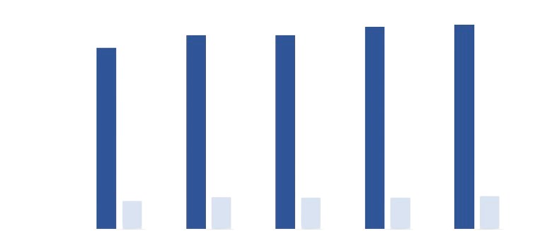

**Jun-24 Sep-24 Dec-24 Mar-25 Jun-25**

**905.4 914.7**

**812.9**

**867.4**

**869.5**

**124**

**143**

**141**

**139**

**137**

#### Revenue v/s EBITDA

*Source: Company Quarterly Data*

**Revenue Breakup**

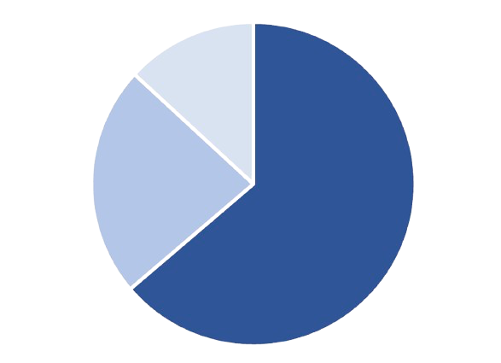

**63.8%**

**23.1%**

**13.1%**

*Source: Mastek Q1 FY26 Quarterly Report*

**UK & Europe**

**USA**

**AMEA**

##### 

##### Academic Research Project- Not a Recommendation

**Financial Statement Analysis**

**Yearly Income Statement Snapshot**

|  |  |  |  |  |  |  |  |  |  |  |
| --- | --- | --- | --- | --- | --- | --- | --- | --- | --- | --- |
| **Particulars** | **Mar-16** | **Mar-17** | **Mar-18** | **Mar-19** | **Mar-20** | **Mar-21** | **Mar-22** | **Mar-23** | **Mar-24** | **Mar-25** |
| Sales | 527 | 560 | 817 | 1,033 | 1,071 | 1,722 | 2,184 | 2,563 | 3,055 | 3,455 |
| *% Growth YOY* | *-47.96%* | *6.26%* | *45.89%* | *26.44%* | *3.68%* | *60.78%* | *26.83%* | *17.35%* | *19.20%* | *13.09%* |
| Expenses | 509 | 515 | 718 | 902 | 916 | 1,357 | 1,721 | 2,108 | 2,546 | 2,909 |
| *Gross Margin %* | *42%* | *39%* | *39%* | *41%* | *43%* | *46%* | *48%* | *44%* | *43%* | *44%* |
| **EBITDA** | **18** | **45** | **100** | **132** | **156** | **364** | **463** | **456** | **509** | **546** |
| *EBITDA Margins (%)* | *3.42%* | *8.04%* | *12.24%* | *12.78%* | *14.57%* | *21.14%* | *21.20%* | *17.79%* | *16.66%* | *15.80%* |
| Other Income | 15 | 12 | 21 | 25 | 17 | 28 | 36 | 64 | 12 | 30 |
| Interest | 0 | 4 | 6 | 6 | 4 | 8 | 8 | 25 | 44 | 42 |
| Depreciation | 16 | 15 | 19 | 17 | 25 | 45 | 43 | 67 | 90 | 75 |
| **Profit before tax** | **16** | **39** | **96** | **133** | **144** | **339** | **448** | **427** | **386** | **459** |
| Tax | 2 | 7 | 26 | 32 | 30 | 87 | 115 | 117 | 75 | 83 |
| **Net Profit** | **14** | **32** | **70** | **101** | **114** | **252** | **333** | **310** | **311** | **376** |
| *Net profit Margin %* | *2.66%* | *5.71%* | *8.57%* | *9.78%* | *10.64%* | *14.63%* | *15.25%* | *12.10%* | *10.18%* | *10.88%* |
| *Net Profit growth YOY (%)* | *-22.22%* | *128.57%* | *118.75%* | *44.29%* | *12.87%* | *121.05%* | *32.14%* | *-6.91%* | *0.32%* | *20.90%* |

*Source: Screener.com*

**Commentary**

Mastek Ltd. has steadily evolved into a resilient and operationally disciplined mid-cap IT services provider. Over the last five years, the company has delivered a **median annual revenue growth of approximately 19%**, with **13.1% YoY growth reported in FY25**—a strong performance considering the broader macroeconomic headwinds. This consistent topline expansion reflects Mastek’s strategic focus on digital transformation, client mining, and execution strength across core markets.

Profitability has seen a structural improvement over the years. **Gross margins increased from 39% in FY18 to 44% in FY25**, supported by enhanced delivery efficiencies and a focus on high-value engagements. **EBITDA margins expanded from 3.4% in FY16 to 15.8% in FY25**, highlighting improved operational leverage and prudent cost controls. Similarly, **net profit margins rose to 10.9% in FY25**, with a robust **20.9% YoY net profit growth**, reflecting Mastek’s ability to sustain bottom-line strength even as it invests in future capabilities.



***Mar-17 Mar-18 Mar-19 Mar-20 Mar-21 Mar-22 Mar-23 Mar-24 Mar-25***

**51.0%**

**41.0%**

**31.05**

**21.0%**

**11.0%**

**1.0%**

**Margin Trend (%)**

*Source: Company Analysis*

**Gross Margin %**

**Net Margin %**

**EBITDA Margins (%)**

Business Segment Revenue Contribution in FY25:

1. Digital Application & Engineering: 46.50%
2. Oracle cloud & Enterprise Apps: 31.30%
3. Digital commerce & Experience: 13%
4. Data Automation & AI: 9.20%

Compared to larger peers, Mastek’s EBITDA margins are modest; however, it stands out for its **net profit margin stability**, particularly over the last five quarters. In a landscape where Tier-1 IT firms have faced earnings volatility, Mastek’s consistent margin profile underscores its solid execution, lean cost structure, and quality of earnings.

##### Academic Research Project- Not a Recommendation

**Financial Statement Analysis**

**Balance Sheet Snapshot**

|  |  |  |  |  |  |  |
| --- | --- | --- | --- | --- | --- | --- |
|  | **Mar-20** | **Mar-21** | **Mar-22** | **Mar-23** | **Mar-24** | **Mar-25** |
| Equity Share Capital | 12 | 13 | 15 | 15 | 15 | 15 |
| Reserves | 778 | 846 | 1,056 | 1,668 | 2,072 | 2,447 |
| Borrowings | 335 | 273 | 203 | 404 | 519 | 583 |
| Other Liabilities | 763 | 1,146 | 1,193 | 1,024 | 1,045 | 817 |
| **Total Liabilities** | **1,888** | **2,277** | **2,467** | **3,111** | **3,652** | **3,863** |
|  |  |  |  |  |  |  |
| Fixed Assets | 857 | 807 | 841 | 1,740 | 1,950 | 1,818 |
| Capital Work in Progress | 2 | 2 | 4 | 7 | 1 | 2 |
| Investments | 276 | 234 | 26 | 69 | 94 | 178 |
| Other Assets | 754 | 1,235 | 1,596 | 1,296 | 1,607 | 1,865 |
| **Total Assets** | **1,888** | **2,277** | **2,467** | **3,111** | **3,652** | **3,863** |

*Source: Screener.in*

**Fixed Asset Analysis**

|  |  |  |  |  |  |  |
| --- | --- | --- | --- | --- | --- | --- |
|  | **Mar-20** | **Mar-21** | **Mar-22** | **Mar-23** | **Mar-24** | **Mar-25** |
| Revenue | 1,071 | 1,722 | 2,184 | 2,563 | 3,055 | 3,455 |
| Gross Block | 1,072 | 1,023 | 1,097 | 2,056 | 2,313 | 2,258 |
| Accumulated Depreciation | 215 | 217 | 256 | 316 | 363 | 440 |
| **Net Fixed Asset** | **857** | **806** | **841** | **1,740** | **1,950** | **1,818** |
| Change in Revenue | 727 | 650 | 462 | 380 | 491 | 400 |
| Change in Gross Block | 728 | -49 | 74 | 959 | 257 | -55 |
| **Change in Revenue/Change in Gross Block** | **1.0x** | **-13.3x** | **6.2x** | **0.4x** | **1.9x** | **-7.3x** |

*Source: Screener.in*

**Commentary**

Over the last five years, the company’s total assets have doubled from ₹1,888 crores in FY20 to ₹3,863 crores in FY25, supported by rising reserves and increased borrowings (₹335 crores to ₹583 crores). While this indicates growth, the reliance on debt and flattening asset additions suggest a cautious capital structure. Net fixed assets peaked at ₹1,950 crores in FY24 but declined to ₹1,818 crores in FY25, despite revenue rising to ₹3,455 crores. According to Screener.in, the company generated **1.9x revenue per unit of net fixed asset** in FY24, indicating efficient asset use.

##### However, the **change in revenue to change in **gross block turned negative (-7.3x)****, as revenue rose while gross block shrank. This implies recent growth has come from existing capacity rather than fresh investments. While past performance reflects strong asset utilization, the FY25 figures raise questions about the sustainability of growth without corresponding capital expansion.

##### A blue and orange text on a black background AI-generated content may be incorrect. Academic Research Project- Not a Recommendation

**Trade Receivables Analysis**

**Financial Statement Analysis**

|  |  |  |  |  |  |  |
| --- | --- | --- | --- | --- | --- | --- |
| **Particulars** | **Mar-20** | **Mar-21** | **Mar-22** | **Mar-23** | **Mar-24** | **Mar-25** |
| Sales | 1,071 | 1,722 | 2,184 | 2,563 | 3,055 | 3,455 |
| *Sales Growth YOY%* | *3.70%* | *60.70%* | *26.83%* | *17.38%* | *19.17%* | *13.11%* |
| Trade receivables | 316 | 375 | 436 | 507 | 561 | 738 |
| *Receivable Growth (YoY %)* | *51.43%* | *18.74%* | *16.19%* | *16.31%* | *10.79%* | *31.41%* |
| Receivables as % of Revenue | 29.47% | 21.77% | 19.95% | 19.76% | 18.37% | 21.35% |
| Receivable Days | 108 | 79 | 73 | 72 | 67 | 78 |
| Receivable turnover | 1.2 | 1.09 | 1.07 | 1.08 | 1.05 | 1.14 |

*Source: Company Analysis*

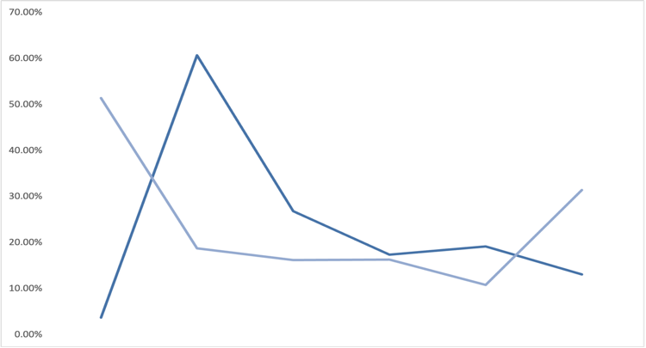

**Sales Growth v/s Receivable Growth**

**Mar-21 Mar-22 Mar-23 Mar-24 Mar-25**

*Source: Company Analysis*

**Sales Growth YOY%**

**Receivable Growth YOY%**

**60.0%**

**50.0%**

**40.0%**

**30.0%**

**20.0%**

**10.0%**

**0.0%**

|  |  |  |  |
| --- | --- | --- | --- |
| **Peers** | **Mar 2023** | **Mar 2024** | **Mar 2025** |
| TCS | 81 | 81 | 84 |
| Infosys | 63 | 72 | 70 |
| HCL Tech | 92 | 85 | 81 |
| Wipro | 51 | 47 | 48 |
| Median | 72 | 77 | 76 |
| Mastek | 72 | 67 | 78 |

*Source: Company Analysis*

**Peer Analysis**

**Median**

**Mar-20 Mar-21 Mar-22 Mar-23 Mar-24 Mar-25**

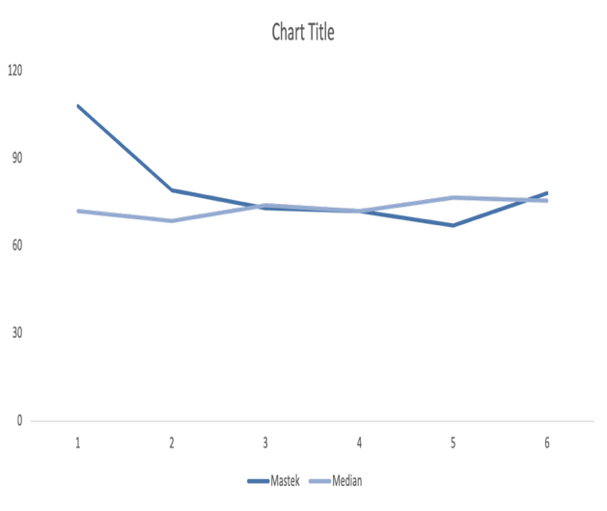

**120**

**90**

**60**

**30**

**0**

**Mastek**

*Source: Company Analysis*

#### Trade Receivable Days

**Commentary**

Over the past five years, Mastek has maintained a relatively balanced correlation between its revenue and receivables growth. Sales grew from ₹1,071 Cr in FY20 to ₹3,455 Cr in FY25 (CAGR -28%), while trade receivables increased from ₹316 Cr to ₹738 Cr (CAGR -19%). Notably, receivable growth has typically remained below revenue growth, suggesting a disciplined approach to collections. However, FY25 marked a divergence, with receivables rising 31.4% against sales growth of 13.1%, indicating a potential slowdown in collections that merits observation.

Receivables as a percentage of revenue improved from 29.5% in FY20 to 18.4% in FY24, reflecting better working capital efficiency. This ratio increased to 21.4% in FY25, indicating a mild stretch in receivables, possibly due to a lag in client payments or changing billing cycles.

Mastek’s receivable days declined steadily from 108 days in FY20 to 67 days in FY24, before rising to 78 days in FY25. While this increase reverses the improving trend, Mastek still compares well to the FY25 industry median of 76 days, and remains broadly in line with peers like TCS (84) and Infosys (70). The uptick does not suggest immediate credit risk but should be monitored.

Receivables turnover ratio has remained stable, ranging between 1.05x and 1.14x, with FY25 showing the highest value in five years—indicating relatively improved efficiency despite longer collection periods.

In summary, Mastek’s receivables management remains largely healthy, supported by stable turnover ratios and controlled receivable levels relative to revenue. While the FY25 figures show early signs of collection softening, they remain within industry norms and do not currently signal elevated credit risk. Ongoing monitoring will be key in assessing whether this is a temporary deviation or an emerging trend.

##### Academic Research Project- Not a Recommendation

**Financial Statement Analysis**

**Cash Flow Statement**

|  |  |  |  |  |  |
| --- | --- | --- | --- | --- | --- |
| **Particulars** | **Mar-21** | **Mar-22** | **Mar-23** | **Mar-24** | **Mar-25** |
| **Operating Activity** |  |  |  |  |  |
| Profit from Operations | **388** | **489** | **506** | **546** | **581** |
| Receivables | -45 | -136 | -138 | -8 | -12 |
| Payables | 8 | 66 | -115 | 29 | 8 |
| Loans Advances | -15 | -37 | 0 | 0 | 0 |
| Other WC Items | 0 | 0 | -9 | -39 | -59 |
| **Working Capital Changes** | **-53** | **-107** | **-262** | **-18** | **-63** |
| Direct Taxes | -48 | -109 | -136 | -107 | -122 |
| Other Operating Items | 0 | 0 | 0 | 0 | 0 |
| **Cash from Operating Act.** | **287** | **273** | **108** | **420** | **395** |
| **Investing Activity** |  |  |  |  |  |
| Fixed Assets Purchased | -12 | -37 | -32 | -31 | -20 |
| Fixed Assets Sold | 0 | 0 | 49 | 2 | 1 |
| Capital WIP | 0 | 0 | 0 | 0 | 0 |
| Investments Purchased | -230 | -281 | -246 | -346 | -463 |
| Investments Sold | 432 | 447 | 218 | 328 | 387 |
| Interest Received | 3 | 4 | 4 | 1 | 7 |
| Dividends Received | 0 | 0 | 0 | 0 | 0 |
| Acquisition of Companies | 0 | -166 | -755 | -194 | -205 |
| Other Investing Items | 24 | 8 | 43 | -8 | 34 |
| **Cash from Investing Act.** | **218** | **-26** | **-719** | **-249** | **-259** |
| **Financing Activity** |  |  |  |  |  |
| Proceeds from Shares | 8 | 2 | 3 | 0 | 0 |
| Proceeds from Borrowings | 0 | 2 | 245 | 184 | 444 |
| Repayment of Borrowings | -94 | -73 | -71 | -81 | -385 |
| Interest Paid | -9 | -5 | -18 | -31 | -42 |
| Dividends Paid | -14 | -48 | -57 | -58 | -59 |
| Financial Liabilities | -9 | -7 | -8 | -12 | -15 |
| Other Financing Items | 0 | 0 | 0 | 0 | 0 |
| **Cash from Financing Act.** | **-118** | **-128** | **93** | **2** | **-57** |
| **Net Cash Flow** | **387** | **119** | **-519** | **173** | **80** |
|  |  |  |  |  |  |
| **EBITDA** | **364.47** | **462.51** | **455.85** | **508.67** | **546.45** |
| **CFO/EBITDA** | **78.74%** | **59.03%** | **23.69%** | **82.57%** | **72.28%** |

*Source: Screener*

**Commentary**

Over the past five years, Mastek’s cash flow from operations (CFO) has shown volatility despite a steady rise in EBITDA, signaling underlying inefficiencies. In FY21 and FY22, CFO was healthy at ₹287 Cr and ₹273 Cr, but it dropped sharply to ₹108 Cr in FY23 due to a significant rise in working capital requirements (₹262 Cr outflow). Though EBITDA improved to ₹455.85 Cr that year, the CFO/EBITDA ratio fell to just 23.69%, highlighting weak cash conversion. While FY24 and FY25 saw recovery in CFO to ₹420 Cr and ₹395 Cr, the five-year trend suggests inconsistent cash flow generation, largely driven by fluctuating working capital and not core profitability.

**Academic Research Project- Not a Recommendation**

**Financial Statement Analysis**

**Financial Summary**

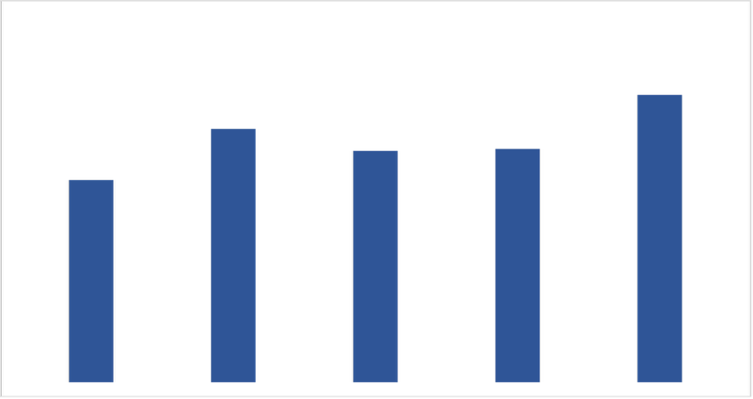

**₹84.9**

**₹106.5**

**₹97.2**

**₹98.0**

**₹120.7**

**Mar-21 Mar-22 Mar-23 Mar-24 Mar-25**

*Source: Company Analysis*

**EPS (in ₹)**

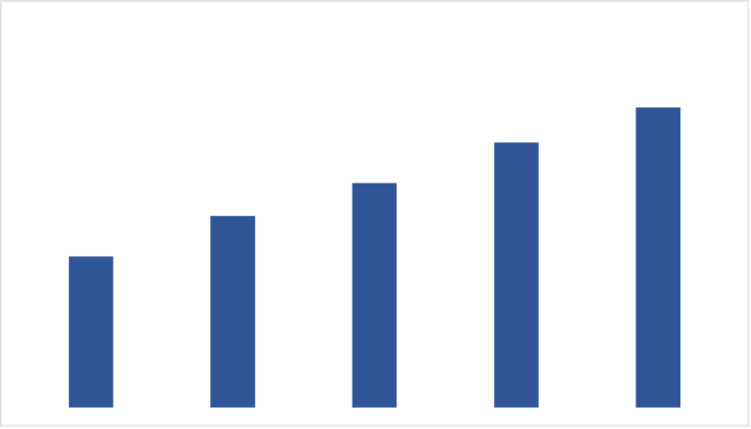

**₹1,749.8**

**₹2,219.9**

**₹2,601.7**

**₹3,070.8**

**₹3,477.5**

**Mar-21 Mar-22 Mar-23 Mar-24 Mar-25**

*Source: Company Analysis*

#### Revenue From Operations (in ₹ Cr.)

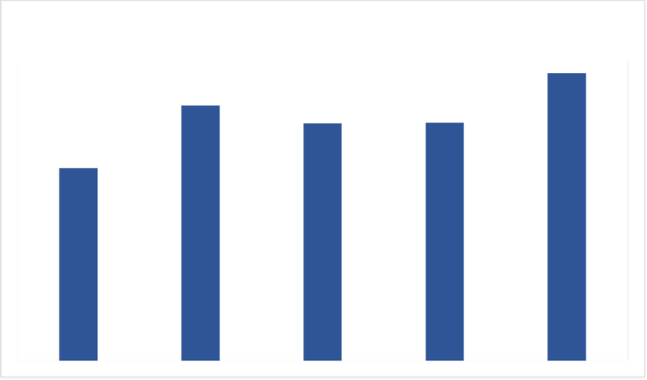

**₹251.7**

**₹333.4**

**₹310.3**

**₹311.0**

**₹375.9**

**Mar-21 Mar-22 Mar-23 Mar-24 Mar-25**

*Source: Company Analysis*

#### Net Profit (in ₹ Cr.)

**Mar-21 Mar-22 Mar-23 Mar-24 Mar-25**

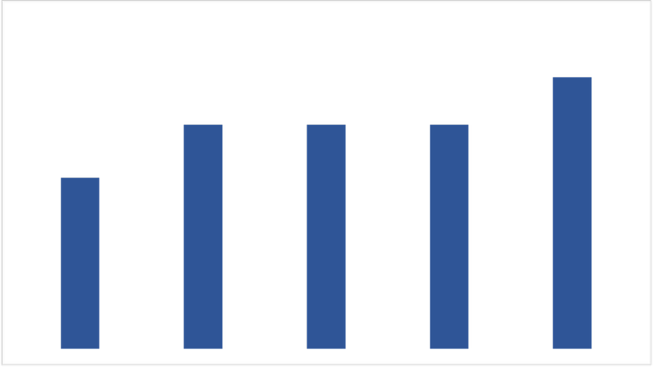

**₹14.5**

**₹23**

**₹19**

**₹19**

**₹19**

#### Dividend Per Share (in ₹)

*Source: Company Analysis*

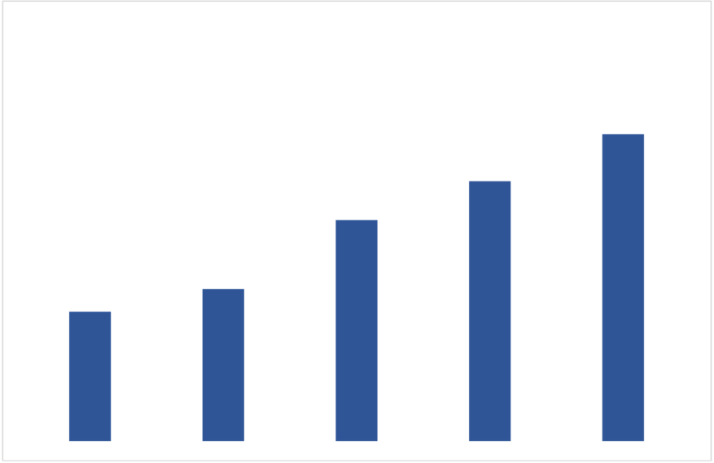

**Mar-21 Mar-22 Mar-23 Mar-24 Mar-25**

*Source: Company Analysis*

**₹1,040.6**

**₹2,462.3**

**₹1,774.5**

**₹2,087.4**

**₹1,221.7**

**Net Worth (in ₹ Cr.)**

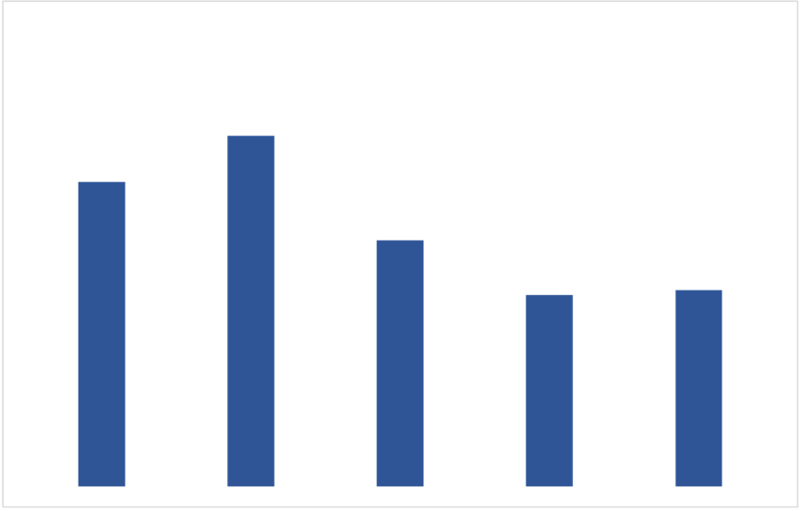

**Mar-21 Mar-22 Mar-23 Mar-24 Mar-25**

*Source: Company Analysis*

**20.7%**

**29.5%**

**16.1%**

**16.5%**

**25.6%**

#### Return on Equity

##### Academic Research Project- Not a Recommendation

**Financial Statement Analysis**

**DU PONT Analysis**

|  |  |  |  |  |  |  |
| --- | --- | --- | --- | --- | --- | --- |
| **Return on Equity** | **Mar-20** | **Mar-21** | **Mar-22** | **Mar-23** | **Mar-24** | **Mar-25** |
| Net Profit | 113.81 | 251.75 | 333.42 | 310.27 | 310.97 | 375.93 |
| Revenue | 1,071.48 | 1,721.86 | 2,183.84 | 2,563.39 | 3,054.79 | 3,455.23 |
| **Net Profit Margin (A)** | **10.6%** | **14.6%** | **15.2%** | **12.1%** | **10.1%** | **10.9%** |
| Revenue | 1,071.48 | 1,721.86 | 2,183.84 | 2,563.39 | 3,054.79 | 3,455.23 |
| Average Total Assets | 1,444.65 | 2,099.07 | 2,391.96 | 2,814.54 | 3,413.02 | 3,773.51 |
| **Asset Turnover Ratio (B)** | **0.74** | **0.82** | **0.91** | **0.91** | **0.89** | **0.91** |
| Average Total Assets | 1,444.65 | 2,099.07 | 2,391.96 | 2,814.54 | 3,413.02 | 3,773.51 |
| Average Shareholders Equity | 821.05 | 984.04 | 1,131.14 | 1,498.11 | 1,930.96 | 2,274.88 |
| **Equity Multiplier (C)** | **1.76** | **2.13** | **2.11** | **1.88** | **1.77** | **1.66** |
|  |  |  |  |  |  |  |
| **Return On Equity (A*B*C)** | **13.8%** | **25.5%** | **29.2%** | **20.7%** | **15.9%** | **16.4%** |

*Source: Company Analysis*

**Peer Analysis**

|  |  |  |  |  |
| --- | --- | --- | --- | --- |
| **Net Profit Margin**  **(A)** | | **Asset Turnover Ratio**  **(B)** | **Equity Multiplier**  **(C)** | **Return On Equity**  **(A*B*C)** |
| TCS | 19.11% | 1.68 | 1.64 | 52.65% |
| Infosys | 16.41% | 1.14 | 1.55 | 29.00% |
| HCL Tech | 14.86% | 1.15 | 1.48 | 25.29% |
| Wipro | 14.83% | 0.73 | 1.54 | 16.67% |
|  |  |  |  |  |
| **Average** | 16.30% | 1.18 | 1.55 | 30.9% |
| **Median** | 15.64% | 1.15 | 1.55 | 27.1% |
| **Mastek** | 10.90% | 0.91 | 1.66 | 16.4% |

*Source: Company Analysis*

**Commentary**

Mastek reported a Return on Equity (ROE) of **16.4% in FY25**, which, while stable, remains below the **peer median of 27.1%** and **industry average of 30.9%**. The key factor limiting its ROE is a **low Net Profit Margin of 10.9%**, significantly trailing competitors like TCS (19.1%) and Infosys (16.4%).

On the positive side, Mastek demonstrates solid operational efficiency with an **Asset Turnover Ratio of 0.91**, comparable to larger peers and above Wipro (0.73), indicating effective use of its asset base to generate revenue. Its **Equity Multiplier of 1.66** reflects moderate financial leverage, slightly above the industry average, providing some lift to ROE without excessive risk.

To close the gap with top-tier peers, Mastek must focus on **margin improvement**, possibly by expanding into **higher-margin digital services**, optimizing costs, and driving scale. Sustaining asset efficiency will be key to long-term ROE enhancement.

##### Academic Research Project- Not a Recommendation

**Financial Statement Analysis**

**Capital Allocation Ratios**

**Return on Capital Employed**

|  |  |  |  |  |  |
| --- | --- | --- | --- | --- | --- |
|  | **Mar-21** | **Mar-22** | **Mar-23** | **Mar-24** | **Mar-25** |
| NOPAT | 237.05 | 312.29 | 282.04 | 337.20 | 385.89 |
| Revenue | 1721.86 | 2183.84 | 2563.39 | 3054.79 | 3455.23 |
| **NOPAT Margin (A)** | **13.77%** | **14.30%** | **11.00%** | **11.04%** | **11.17%** |
|  |  |  |  |  |  |
| Revenue | 1721.86 | 2183.84 | 2563.39 | 3054.79 | 3455.23 |
| Average Capital Employed | 863.845 | 701.485 | 1333.865 | 2097.01 | 2403.88 |
| **Capital Turnover Ratio (B)** | **1.99** | **3.11** | **1.92** | **1.46** | **1.44** |
|  |  |  |  |  |  |
| **Return On Capital Employed (A*B)** | **27.44%** | **44.52%** | **21.14%** | **16.08%** | **16.05%** |

*Source: Company Analysis*

**Return On Assets**

|  |  |  |  |  |  |
| --- | --- | --- | --- | --- | --- |
|  | **Mar-21** | **Mar-22** | **Mar-23** | **Mar-24** | **Mar-25** |
| Net Profit | 251.75 | 333.42 | 310.27 | 310.97 | 375.93 |
| Revenue | 1721.86 | 2183.84 | 2563.39 | 3054.79 | 3455.23 |
| **Net Profit Margin (A)** | **14.62%** | **15.27%** | **12.10%** | **10.18%** | **10.88%** |
|  |  |  |  |  |  |
| Revenue | 1721.86 | 2183.84 | 2563.39 | 3054.79 | 3455.23 |
| Average Total Assets | 2099.08 | 2391.96 | 2814.54 | 3413.02 | 3773.51 |
| **Asset Turnover Ratio (B)** | **0.82** | **0.91** | **0.91** | **0.90** | **0.92** |
|  |  |  |  |  |  |
| **Return On Assets (A*B)** | **11.99%** | **13.94%** | **11.02%** | **9.11%** | **9.96%** |

*Source: Company Analysis*

**Peer Analysis**

*Source: Company Analysis*

**Mastek**

**TCS**

**Infosys**

**HCL Tech**

**Wipro**

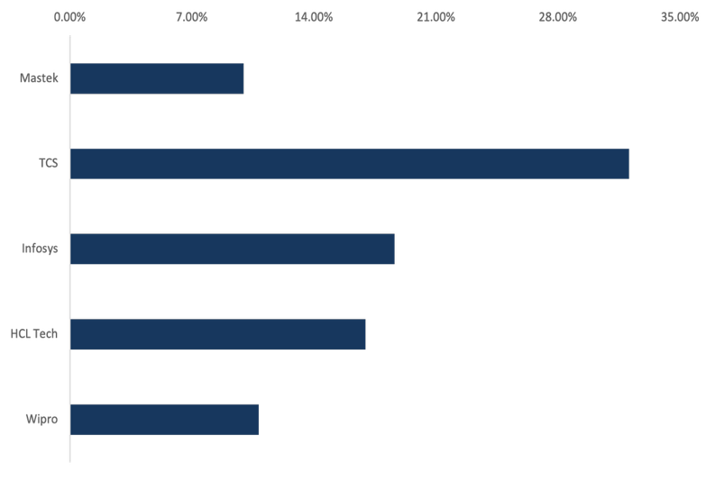

**18.62%**

**32.07%**

**9.96%**

**10.82%**

**16.95%**

**Return On Assets**

*Source: Company Analysis*

**Mastek**

**TCS**

**Infosys**

**HCL Tech**

**Wipro**

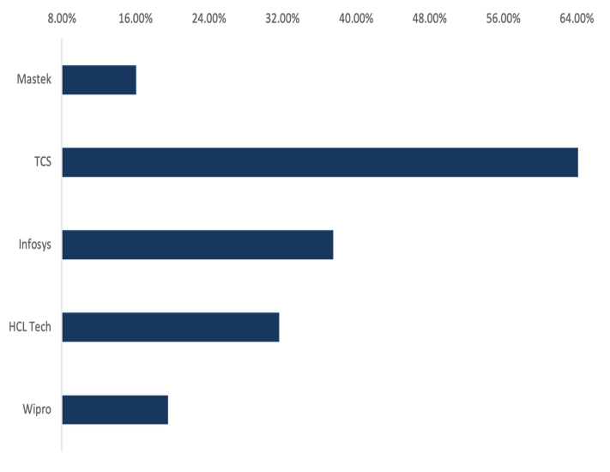

**64.63%**

**19.51%**

**16.05%**

**37.50%**

**31.61%**

**Return On Capital Employed**

##### Academic Research Project- Not a Recommendation

**Financial Statement Analysis**

**Capital Allocation Ratios**

**Commentary**

Mastek’s **Return on Capital Employed (ROCE)** has remained modest over the years, averaging around 16%, which suggests the company is generating fair returns relative to the capital it employs. However, when compared to industry leaders such as TCS (64.63%) and Infosys (37.50%), Mastek’s ROCE indicates a more **conservative capital efficiency profile**. This could be attributed to Mastek’s focus on long-term growth initiatives and investments, which may take time to fully translate into higher returns.

The company’s **Return on Assets (ROA)** has seen a downward shift, falling from **13.94% in FY22 to 9.96% in FY25**, mainly due to a combination of **margin compression and a growing asset base**. The net profit margin has gradually declined over the years, from 15.27% to 10.88%, putting pressure on overall returns. Despite this, Mastek continues to outperform some peers like Wipro (10.82%) in ROA, but lags behind major players such as TCS (32.07%) and Infosys (18.62%).

While the **Asset Turnover Ratio has remained relatively stable** around 0.90–0.92 in recent years, it indicates that revenue generation relative to assets hasn’t significantly improved, even as total assets have grown. This implies Mastek may need to focus more on **extracting higher revenue from its expanding asset base** to enhance returns.

To close the gap with top-tier peers, Mastek must emphasize **improving operational efficiency**, **reversing margin erosion**, and ensuring that **capital investments generate proportional revenue and profit growth** in the coming years.

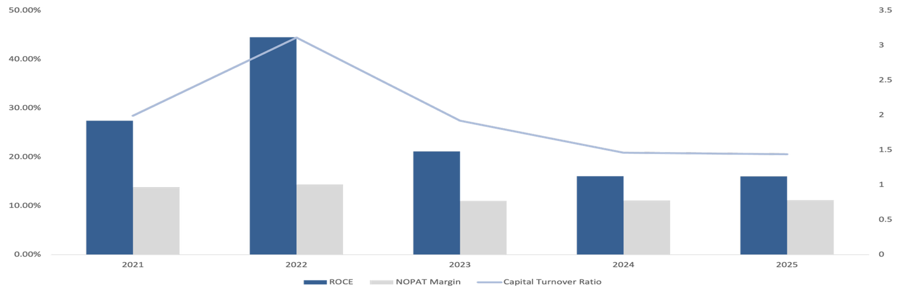

**50.0%**

**40.0%**

**30.0%**

**20.0%**

**10.0%**

**0.0%**

**3.5**

**3.0**

**2.5**

**2.0**

**1.5**

**1.0**

**0.5**

**ROCE NOPAT Margin Capital turnover ratio**

**Return On Capital Employed (ROCE)**

*Source: Company Analysis*

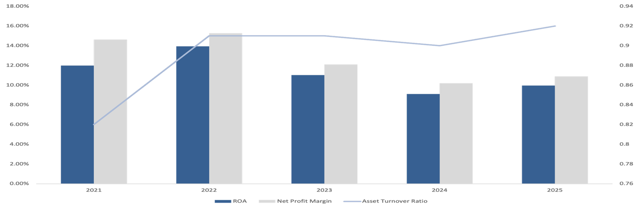

**18.0%**

**16.0%**

**14.0%**

**12.0%**

**10.0%**

**8.0%**

**6.0%**

**4.0%**

**2.0%**

**0.0%**

**ROA Net profit Margin Asset turnover ratio**

**0.94**

**0.92**

**0.90**

**0.88**

**0.86**

**0.84**

**0.82**

**0.80**

**0.78**

**0.76**

**Return On Assets (ROA)**

*Source: Company Analysis*

##### Academic Research Project- Not a Recommendation

**Financial Statement Analysis**

**Capital Allocation Ratios**

**Return on Incremental Invested Capital**

|  |  |  |  |  |  |  |
| --- | --- | --- | --- | --- | --- | --- |
|  | **Mar-20** | **Mar-21** | **Mar-22** | **Mar-23** | **Mar-24** | **Mar-25** |
| Net income | 113.81 | 251.75 | 333.42 | 310.27 | 310.97 | 375.93 |
| Capital Employed | 1022.19 | 705.5 | 697.47 | 1,970.26 | 2,223.76 | 2,584.00 |

**Commentary**

|  |  |
| --- | --- |
| **ROIIC Profiling** |  |
| Cumulative Net Income (A) | 1,696.15 |
| Incremental Capital Deployed (B) | 1561.81 |
| **Reinvestment Rate (B/A)** | **92.08%** |
| Change in Net Income (C) | 262.12 |
| ROIIC (C/B) | 16.78% |
| **Intrinsic Compounding Rate** | **15.45%** |
| *(Reinvestment rate * ROIIC)* |  |
| **Stock Price (5 Year CAGR)** | **29.00%** |

Over the past five years, Mastek has delivered a **Return on Incremental Invested Capital (ROIIC) of 16.78%**, indicating a disciplined and effective approach to capital allocation. This metric reflects the company’s ability to generate meaningful returns on the additional capital deployed during this period. With **cumulative net income of ₹1,696.15 crore** and **incremental capital deployed of ₹1,561.81 crore**, Mastek has demonstrated that its reinvestments are yielding above-average returns, which is a positive indicator for long-term value creation. The **reinvestment rate of 92.08%** highlights Mastek’s strategy of redeploying a substantial portion of its earnings back into the business. Such a high reinvestment rate, when coupled with a solid ROIIC, translates into a **strong intrinsic compounding rate of 15.45%**, showcasing the company’s ability to grow shareholder value internally without excessive dependence on external financing.

*Source: Company Analysis*

However, a deeper look at the **Net Income vs. Capital Employed trend** shows a steep rise in capital employed post FY22, while net income growth has been relatively modest. This divergence suggests that although the company has ramped up investments—likely in infrastructure, technology, and talent—these investments are yet to deliver commensurate earnings growth. Going forward, **translating this capital base into accelerated earnings will be key** to maintaining ROIIC momentum.

**Mar-20 Mar-21 Mar-22 Mar23 Mar-24 Mar-25**

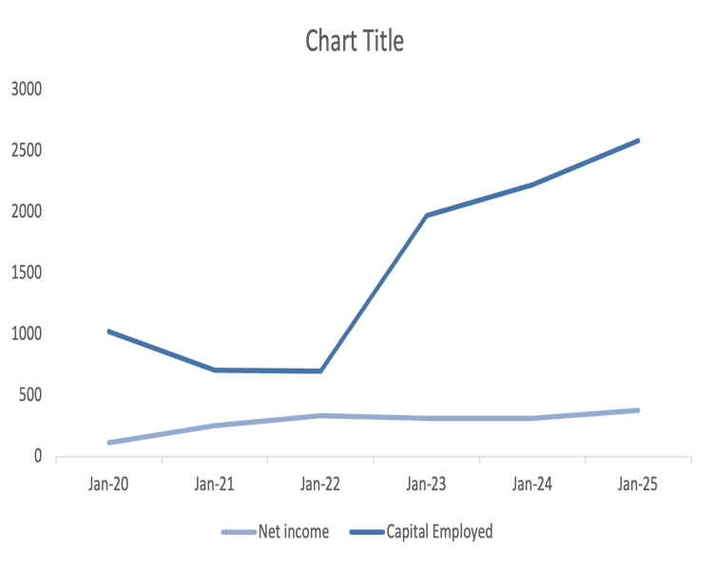

**3,000**

**2,500**

**2,000**

**1,500**

**1,000**

**500**

**0**

**Net Income Capital Employed**

*Source: Company Analysis*

#### Net Income v/s Capital Employed

The company’s **5-year stock price CAGR of 29%** indicates that investors have largely priced in the long-term growth potential of these investments. However, to sustain these valuations, Mastek must continue to **optimize capital productivity**, improve **margin resilience**, and extract better **returns on incremental deployments**.

In conclusion, Mastek’s strong ROIIC and high reinvestment rate paint a favourable picture, but execution on translating capital into higher profits will determine the sustainability of its compounding trajectory.

**Academic Research Project- Not a Recommendation**

**Qualitative Analysis**

**Strengths**

**SWOT Analysis**

* **Extensive Global Reach**

Mastek maintains a strong international presence, with a strategic focus on the UK, US, and European markets. Its global delivery model allows it to serve both public and private sector clients across regions, enabling scalability and localization of services.

* **Diverse Business Portfolio**  
  The company offers a wide range of services including cloud transformation, digital engineering, data analytics, cybersecurity, and AI solutions. This diversified portfolio enables Mastek to cater to various industries and adapt to evolving technology trends.
* **Strong Client Relationships**  
  Mastek has built long-term partnerships through a consultative approach, delivering tailored solutions. High CSAT scores (e.g., 5.66/7 across accounts) reflect strong customer satisfaction and retention across strategic accounts.
* **Sound Expertise in the Public Sector**  
  With decades of experience, Mastek plays a critical role in UK public sector projects, including defence, immigration, healthcare, and justice. Its involvement in high-impact government digital transformation initiatives adds to its credibility.
* **Dynamic Innovation Supported by Dedicated R&D**  
  Significant investments in AI and proprietary platforms (e.g., Mastek AI Galaxy, Lightbeam, AI Optimization Engine) drive continuous innovation. Mastek’s AI Centers of Excellence and AI Academy support scalable, future-ready solutions through strong in-house R&D and workforce upskilling.

**Weaknesses**

* **Promoter Decreasing Shareholding**

A decline in promoter stake can signal reduced confidence from the company's founders or key stakeholders, which may concern investors.

* **Growing Costs YoY for Long-Term Projects**

Rising year-over-year costs, especially for long-term projects, can impact profitability and reflect inefficiencies or poor cost control.

* **Declining Net Cash Flow**

Inability to generate positive net cash flow indicates operational inefficiencies or over-dependence on external funding. This could affect liquidity and long-term sustainability.

* **Increasing Trend in Non-Core Income**

A growing share of income from non-core sources may suggest that core business operations are underperforming or stagnating.

**Academic Research Project- Not a Recommendation**

**Qualitative Analysis**

**SWOT Analysis**

**Opportunities**

* **Leverage AI at Scale**  
  There is significant potential to deploy AI-driven automation and personalization to enhance customer engagement. Scalable AI solutions can drive measurable outcomes, such as improved user retention, more efficient operations, and tailored digital experiences.
* **Focus on Industry-Specific Solutions**  
  Tailored technology solutions for specific sectors—such as electric vehicles and energy—open new growth avenues. Companies can capitalize on sectoral trends and technological advancements to penetrate emerging markets and deliver specialized value.
* **Emphasis on Improving Internal Efficiency and Productivity**  
  Streamlining internal processes through standardization and automation presents opportunities to reduce costs, improve service consistency, and increase productivity, which in turn can improve margins and scalability.
* **Growth Strategies Fueled by Partnerships**  
  Strategic collaborations in go-to-market efforts, joint R&D, and skill development can accelerate innovation cycles. Partnerships with ecosystem players can enhance solution capabilities and expand market reach.
* **Embrace Sustainability as a Differentiator**  
  Integrating green technologies into operations not only supports compliance with environmental regulations but also strengthens brand equity. Sustainability can serve as a competitive differentiator, driving increased customer loyalty and investor interest.

**Threats**

* **Technology Complexity and Integration Risks**  
  New technologies like hybrid computing, spatial computing, and agentic AI increase system complexity. Integrating these technologies poses orchestration and security challenges, demanding specialised skills and increasing operational risks.
* **Outdated Infrastructure and Legacy Systems**  
  Many organisations still depend on outdated hardware and software. These legacy systems cause compatibility issues, reduce productivity, and expose businesses to security vulnerabilities. Modernisation is necessary but often costly and difficult.
* **Cybersecurity and Digital Risks**  
  Cyber threats are escalating in scale and sophistication, driven by geopolitical risks, systemic incidents, and AI-powered attacks. Organisations must enhance digital resilience and prepare for potential IT crises through proactive risk management.
* **Skill Gaps and Talent Shortage**  
  There is a significant shortage of skilled professionals in areas like AI, ML, data analytics, and cloud computing. Companies must invest in training and upskilling to adapt to rapid technological change and remain competitive.

##### Academic Research Project- Not a Recommendation

**Peer Analysis**

**1 Year Stock Performance Comparison**

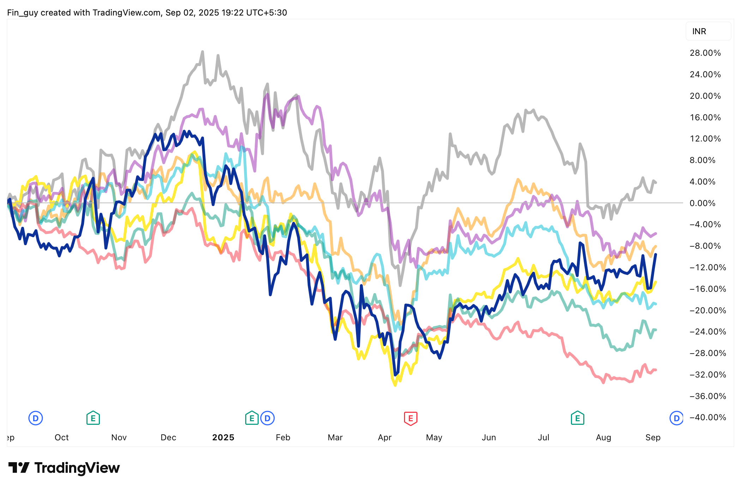

**28.0%**

**24.0%**

**20.0%**

**16.0%**

**12.0%**

**8.0%**

**4.0%**

**0.0%**

**-4.0%**

**-8.0%**

**-12.0%**

**-16.0%**

**-20.0%**

**-24.0%**

**-28.0%**

**-32.0%**

**-36.0%**

**Peer Comparison**

|  |  |  |  |  |  |  |  |  |
| --- | --- | --- | --- | --- | --- | --- | --- | --- |
| **S.No.** | **Name** | **CMP Rs.** | **Debt / Eq** | **PEG Ratio** | **Cash Position** | **OPM %** | **EV Rs.Cr.** | **Prom. Hold. %** |
| 1 | Mastek | 2,454.80 | 0.24 | 2.1 | 461.47 | 15.74 | 7,719.38 | 35.95 |
| 2 | TCS | 3,116.50 | 0.1 | 2.79 | 15,463 | 26.4 | 11,21,505 | 71.77 |
| 3 | Infosys | 1,499.80 | 0.09 | 3.54 | 27,459 | 23.95 | 6,04,098 | 14.61 |
| 4 | HCL Tech | 1,463 | 0.09 | 2.67 | 21,289 | 21.57 | 3,81,996 | 60.81 |
| 5 | Wipro | 251.25 | 0.23 | 8.56 | 12,197 | 20.05 | 2,70,400 | 72.66 |
| 6 | LTIMindtree | 5,149.85 | 0.1 | 6.21 | 3,588 | 16.89 | 1,51,249 | 68.56 |
| 7 | Tech Mahindra | 1,499.90 | 0.07 | -3 | 4,542 | 13.75 | 1,44,364 | 35 |
| 8 | Persistent System | 5,370.50 | 0.05 | 2.05 | 1025 | 17.67 | 83,280 | 30.56 |
|  | **Median** | **313** | **0.07** | **0.88** | **53.34** | **19.39** | **894.71** | **54.85** |

*Source: Screener.com*

##### Academic Research Project- Not a Recommendation

**Consensus Analysis**

**Analyst Coverage**

|  |  |  |  |  |
| --- | --- | --- | --- | --- |
| **Date** | **Author** | **LTP** | **Target** | **Rating** |
| 09-Sep-25 | Consensus Price Target | 2437.30 | 3093.33 | Buy |
| 22-Jul-25 | Anand Rathi | 2437.30 | 3332 | Buy |
| 22-Jul-25 | Geojit BNP Paribas | 2437.30 | 3260 | Buy |
| 21-Apr-25 | Sharekhan | 2437.30 | 3030 | Buy |
| 16-Feb-24 | ICICI Direct | 2437.30 | 1880 | Hold |

*Source: Trendlyne.com*

##### Academic Research Project- Not a Recommendation

**Author’s Opinion**

Mastek Ltd. has strategically positioned itself as a digital engineering and cloud transformation leader, with a sharp focus on innovation, sector-specific solutions, and AI-led growth. The company’s vision revolves around scaling artificial intelligence across the enterprise, driving automation, personalization, and measurable outcomes for its clients. By aligning its capabilities with high-impact sectors such as healthcare, public services, and energy, Mastek is unlocking new growth opportunities in both mature and emerging markets. Its emphasis on improving internal efficiency, strengthening strategic partnerships, and leveraging sustainability as a differentiator reflects a forward-looking, agile approach. These pillars of growth—combined with the company's AI-first framework and focus on co-innovation—enable Mastek to remain resilient in a competitive digital services landscape.

From an efficiency standpoint, Mastek’s revenue rose despite a decline in net fixed assets, reflecting strong asset utilization at 1.9x in FY24. However, negative revenue-to-gross block change suggests growth is driven by existing capacity, not new investments. This indicates operational efficiency but raises concerns about sustaining growth without further capital expansion.

Financially, Mastek's return metrics show a declining trend in ROCE and ROA from FY22 to FY25, indicating weakening efficiency and profitability. Despite steady revenue growth, lower capital and asset turnover ratios reflect reduced operational leverage. Compared to peers like TCS and Infosys, Mastek underperforms significantly, suggesting challenges in value creation and capital utilization efficiency in recent years.

The Company has shown steady growth in its balance sheet over the years, with rising reserves and stable borrowings. The company maintains a balanced approach to asset and liability management. Its financial position indicates the capacity to support capital expenditure and strategic initiatives, reflecting a consistent, disciplined financial structure.

Mastek continues to focus on strategic expansion across the UK public sector and US healthcare market, supported by investments in AI, data, and cloud transformation. With a diverse geographic presence and sectoral focus, Mastek aims to deepen client relationships, enhance delivery excellence, and drive innovation through partnerships, all while navigating leadership transitions and macroeconomic headwinds.

Mastek is well-positioned to leverage its digital engineering expertise, strong presence in the UK and US healthcare markets, and continued investments in AI and cloud transformation to strengthen its global footprint and drive sustainable growth across key sectors and geographies.

**Prepared by – Aman Raj**

***Disclaimer: This is an academic project and is not meant for commercial usage.***

This information/document does not constitute an offer to sell or solicitation for the purchase or sale of any financial instrument or as an official information of any transaction. Recipients will not be treated as any kind of customers solely on the basis of receiving this report. The information contained herein has been obtained from publicly available data and other sources believed to be reliable and the author has not independently verified the accuracy and completeness of the said data and hence it should not be relied upon as such. The author is not a SEBI registered investment analyst. This document is prepared as part of an academic project.

Investments in securities markets are subject to market risks, read all the related documents carefully before investing. The securities quoted are for illustration only and not recommendatory. Registration granted by SEBI and verification from NISM is no way guarantee for performance of the intermediary or provide any assurance of returns to the investors.